SECTION – 1

C Programming Lab

Session 1

Ex 1: Write an interactive program to calculate simple Interest and Compound Interest.

Code:

#include<stdio.h>
#include<conio.h>

void main()
{
float pri,amt,rate,si,ci,time,interest,i,j=1;
clrscr();
printf("\n\n\t\tEnter the principle -> ");
scanf("%f",&pri);
printf("\n\n\t\tEnter the rate -> ");
scanf("%f",&rate);
printf("\n\n\t\tEnter the time In Year -> ");
scanf("%f",&time);
// -------Programm For Simple Interest---------

interest=(pri*rate*time)/100;
si=pri+interest;
printf("\n\n\t\tYour Interest is %f",interest);
printf("\n\n\t\tYour Simple Interest is %f",si);

// ------Programm For Compound Interest--------

for(i=1; i<=time; i++)
{
j=(rate+100)/100*j;
}
ci=pri*j;
interest=ci-pri;
printf("\n\n\t\tYour Interest in Compound is %f",interest);
printf("\n\n\t\tYour Compound Interest is %f",ci);
getch();
}

Output:

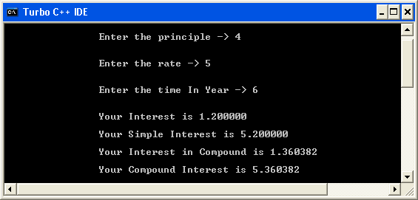

Ex 2: Write an interactive program that uses loop to input the income and calculate and report the owed tax amount. Make sure that your calculation is mathematically accurate and that transaction errors eliminated.
Assume that the United States of America uses the following income tax code formula for their annual income:
First US$ 5000 of income : 0% tax
Next US$ 10,000 of income : 10% tax
Next US$ 20,000 of income : 15% tax
An amount above US$35,000 : 20% tax
For example, somebody earning US$ 38,000 annually would owe
US$5000x0.00+10,000x0.10+20,000x0.15+3000x0.20,
which comes to US$4600.

Code:

#include<stdio.h>
#include<conio.h>
void main()
{
float income,i=0,j=0,k=0,tax=0;
clrscr();
printf("\n\n\t\tEnter Your Income Tax -> ");
scanf("%f",&income);

//--------Calculate The Tax---------

if(income>35000)
{
income=income-35000;
i=10000*.10;
j=20000*.15;
k=income*.20;
tax=i+j+k;
printf("\n\n\t\tYour Tax is %f",tax);
}
else if(income>20000 && income<=35000)
{
income=income-15000;
i=10000*.10;
j=income*.15;
tax=i+j;
printf("\n\n\t\tYour Tax is %f",tax);
}
else if(income>10000 && income<=20000)
{
income=income-15000;
i=10000*.10;
j=income*.15;
tax=i+j;
printf("\n\n\t\tYour Tax is %f",tax);
}
else if(income>5000 && income<=10000)
{
income=income-5000;
tax=income*.10;
printf("\n\n\t\tYour Tax is %f",tax);
}
else
{
printf("\n\n\t\t You have no tax");
}

getch();

}

Output:
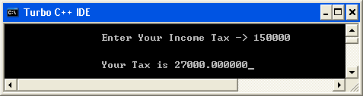

Ex 3: Write an interactive program that reads in integers until a 0 is entered. If it encounters 0 as input, then it should display:
- the total no. of even and odd integers.
- average value of even integers.
- average value of odd integers.
Code:

#include<stdio.h>
#include<conio.h>
void main()
{
int val,even=0,odd=0,sum_even=0,sum_odd=0,avg_even,avg_odd;
clrscr();
first:
printf("\n\n\t\tEnter value -> ");
scanf("%d",&val);
if(val==0)
{
goto last;
}
else if(val%2==0)
{
even++;
sum_even=sum_even+val;
goto first;
}
else
{
odd++;
sum_odd=sum_odd+val;
goto first;
}
last:
avg_even=sum_even/even;
avg_odd=sum_odd/odd;
printf("\n\n\t\tYour Total Even No is %d",even);
printf("\n\n\t\tYour Total Odd No. is %d",odd);
printf("\n\n\t\tYour Avg value of Even is %d",avg_even);
printf("\n\n\t\tYour Avg value of Odd is %d",avg_odd);
getch();
}
Output:
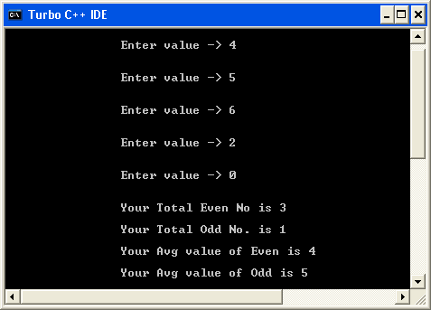

Ex 4: Write an interactive program to generate the divisors of a given integers.

Code:

#include<stdio.h>
#include<conio.h>
void main()
{
int val,i;
clrscr();
printf("\n\n\t\tEnter value ->");
scanf("%d",&val);
for(i=1; i<=val; i++)
{
if(val%i==0)
{
printf("\n\n\t\t %d",i);
}
}
getch();
}

Output:
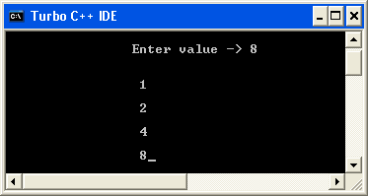

Session 2

Ex 5: Write a program to find all Armstrong Number in the range of 0 and 999.
Code:

#include<stdio.h>
#include<conio.h>
void main()
{
int val,i,j=0,val1;
clrscr();
printf("\n\n\t\tEnter Number To Check Armstrong -> ");
scanf("%d",&val);
val1=val;
while(val>=1)
{
i=val%10;
i=i*i*i;
j=i+j;
val=val/10;
}
if(val1==j)
{
printf("\n\n\t\tYour No Is Armstrong");
}
else
{
printf("\n\n\t\tYour No is Not Armstrong");
}
getch();
}

Output:

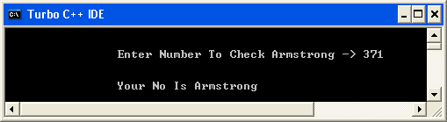

Ex 6: Write a program to check whether a given number is a perfect number or not.

Code:
#include<stdio.h>
#include<conio.h>
void main()
{
int val,i,j=0;
clrscr();
printf("\n\n\tEnter the Number to Check its Perfect or Not -> ");
scanf("%d",&val);
for(i=1; i<val; i++)
{
if(val%i==0)
{
j=j+i;
}
}
if(j==val)
{
printf("\n\n\t\tYour No is Perfect No");
}
else
{
printf("\n\n\t\tYour No is not a perfect no");
}
getch();
}

Output:

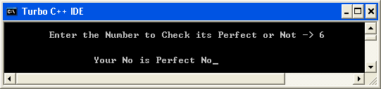

Ex 7: Write a program to check whether given two numbers are amicable numbers or not.

Code:
#include<stdio.h>
#include<conio.h>
void main()
{
int val,val1,i,j=0,k,l=0;
clrscr();
printf("\n\n\t\tEnter first value -> ");
scanf("%d",&val);
printf("\n\n\t\tEnter Second value -> ");
scanf("%d",&val1);
for(i=1; i<val; i++)
{
if(val%i==0)
{
j=j+i;
}
}
for(k=1; k<val1; k++)
{
if(val1%k==0)
{
l=l+k;
}
}
if(l==val && j==val1)
{
printf("\n\n\t\tNo is amicable");
}
else
{
printf("\n\n\t\tNot a Amicable");
}
getch();
}

Output:
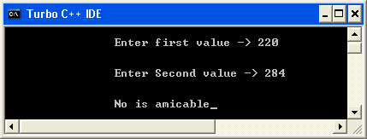

Ex 8: Write a program to find the roots of a quadratic equation.
Code:

#include<stdio.h>
#include<conio.h>
#include<math.h>
#include<process.h>
void main()
{
double a,b,c,d,root1,root2;
clrscr();
printf("\n- A quadratic equation is in the forrm a * x * x + b * x + c = 0");
printf("\n\n- To solve the equation ,please provide the value of a, b & c -");
printf("\n\n a = ");
scanf("%lf", &a);
printf("\n b = ");
scanf("%lf", &b);
printf("\n c = ");
scanf("%lf", &c);
d=(b*b-4*a*c);
if(d<0)
{
printf("\n Cannot claculate roots, as these would be complex numbers.\n");
getch();
exit(0);
}
root1=(-b+sqrt(d))/(2.0*a);
root2=(-b-sqrt(d))/(2.0*a);
printf("\n The roots of the quadratic equation are %lf & %lf", root1,root2);
getch();
}

Output:
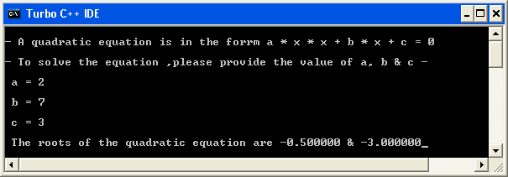

Session 3

Ex 9: Write a function invert(x,p,n) that returns x with the n bits that begin at position p inverted. You can assume that x,p & n are integer variables and that the function will return an integer.

Code:

#include<stdio.h>
#include<conio.h>
#include<math.h>
void main()
{
int intUserInput, intUserInput1, intUserInput2;
int intCompResult;
int invert(int, int, int);
clrscr();
printf("\n\n\t Please insert integer to invert: ");
scanf("%d", &intUserInput);

printf("\n\n\t Please insert starting point to invert: ");
scanf("%d", &intUserInput);

printf("\n\n\t Please insert Length to invert: ");
scanf("%d", &intUserInput2);

intCompResult=invert(intUserInput, intUserInput1, intUserInput2);
printf("\n\n\t Invert no. is : %d", intCompResult);
getch();
}
int invert(int x, int p, int n)
{
int intbinary[8];
int i;
int y;
int r=0;
for(i=0;i<8;i++)
{
intbinary[i]=0;
}
i=0;
y=0;
while(x>0)
{
intbinary[i]=x%2;
x=x/2;
i++;
}
for(i=0;i<8;i++)
{
if(i==p)
{
for(i=p;i>p-n;i--)
{
if(intbinary[i]==0)
{
intbinary[i]=1;
}
else
{
intbinary[i]=0;
}
}
i=i+n;
}
}
for(i=0;i<8;i++)
{
r=r+(intbinary[i]*pow(2,i));
}
return r;
}

Output:

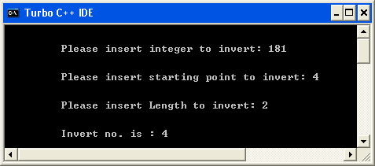

Ex 10: Write a function that calculates the compounded interest amount for a given initial amount, interest rate & no. of years. The interest is compounded annually. The return value will be the interest amount. Use the following function definition: float comp_int_calc(floatint_amt, float rate, int years); Write a program that will accept the initial amount, interest rate & the no. of years and call the function with these values to find out the interest amount and display the returned value.

Code:

#include<stdio.h>
#include<conio.h>
float interest(float int_amt,float rate, int year);
void main()
{
int int_amt,year;
float rate,amt;
clrscr();
printf("\n\n\t Enter the Principle Amt.-> ");
scanf("%d",&int_amt);
printf("\n\n\t Enter the Rate of Interest -> ");
scanf("%f",&rate);
printf("\n\n\t Enter the No. of Years -> ");
scanf("%d",&year);
amt=interest(int_amt,rate,year);
printf("\n\n\t\tYour compound Interest is %f",amt);
getch();
}
float interest(float int_amt,float rate, int year)
{
float interest,amt,ci;
float i,j=1;
for(i=1; i<=year; i++)
{
j=(rate+100)/100*j;
}
interest=int_amt*j;
ci=int_amt+interest;
return ci;
}
Output:
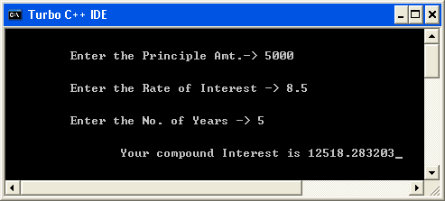

Ex 11: Break up the program that you wrote to solve above problem into two separate source files. The main function should be in one file & the calculation function must be in another file. And modify the program so that the interest rate is a symbolic constant and is no longer input from the keyboard. And put all the C preprocessor directives into a separate header file that is included in the two program source files.

Code:
file-1.c
#include "header.h"
main()
{
float amt,interest;
int year;
float comp_int_calc(float,float,int);
clrscr();
printf("Enter the initial amount: ");
scanf("%f",&amt);
printf("Enter the Number of years: ");
scanf("%f",&year);
interest=comp_int_calc(amt,roi,year);
printf("\nThe int is %.2f",interest);
getch();
}
file-2.c
#include "header.h"
float comp_int_calc(float x,float y,int z)
{
float i;
i=x*pow((1+y/100),2);
return(i-x);
}
header.h
#include<stdio.h>
#include<math.h>
#define roi 10
Then press Alt+P in Turbo C and enter a project file name, e.g. Q11.prj. Create a new project file of the same name e.g. Q11.prj and enter the following in it-
file-1.c
file-2.c
header.h
Now compile the project file and the desired output will be obtained.

Output:
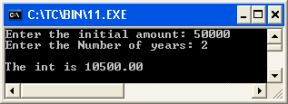

Ex 12: Define two separate macros,MIN & MAX, to find and return, respectively the minimum & maximum of two values. Write a sample program that usesthese macros.

Code:
#include<stdio.h>
#include<conio.h>

#define min(x,y)(x<y ? x:y)
#define max(x,y)(x>y ? x:y)

void main()
{
int i,j;
clrscr();
printf("\n\n\t Enter two numbers to compare :-");
printf("\n\n\tFirst Number -> ");
scanf("%d", &i);
printf("\n\tSecond Number -> ");
scanf("%d", &j);
printf("\n\n\tThe maximum number is %d", max(i,j));
printf("\n\n\tThe minimum number is %d", min(i,j));
getch();
}

Output:
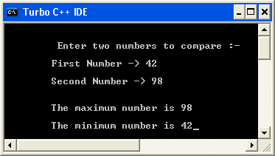

Session 4

Ex 13: Write a program that will take as input a set of integers and find and display the largest and the smallest values within the input data values.

Code:

#include<stdio.h>
#include<conio.h>
void main()
{
int arr[5],i,j,k,ii;
clrscr();
for(i=0; i<5; i++)
{
printf("\n\n\t Enter the Number -> ");
scanf("%d",&arr[i]);
}
i=arr[0];
ii=arr[0];
for(j=0; j<5; j++)
{
if(arr[j]<ii)
{
ii=arr[j];
}
if(arr[j]>i)
{
i=arr[j];
}
}
printf("\n\n\t\tGreatest value is %d",i);
printf("\n\n\t\tSmalles value is %d",ii);
getch();
}

Output:

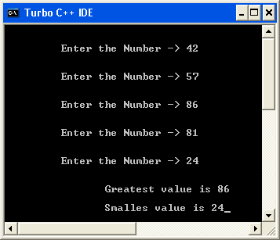

Ex 14: Write an interactive program that will take as input a set of 20 integers and store them in an array and using a temporary array of equal length, reverse the order of the integers & display the values.

Code:

#include<stdio.h>
#include<conio.h>
void main()
{
int arr[20],arr1[20],i,j=0;
clrscr();
//--------Input In First Array-------
printf(" - Enter 20 Integers value to store in Array - \n\n");

for(i=0; i<20; i++)
{
printf("\t Enter value -> ");
scanf("%d",&arr[i]);
}

//-------For Reverse Order--------

for(i=19; i>=0; i--)
{
arr1[j]=arr[i];
j++;
}
getch();
clrscr();

//--------Print First Array------------

printf("\n\n\t\tFirst Array Without Reverse");
for(i=0; i<20; i++)
{
printf("\n\t\t%d",arr[i]);
}
getch();
clrscr();

//-------Print Second Array-------------

printf("\tArray In Reverse Order");
for(i=0;i<19; i++)
{
printf("\n\t\t%d",arr1[i]);
}

getch();
}

Output:

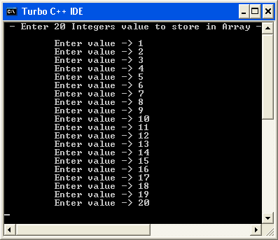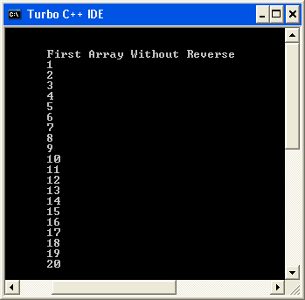

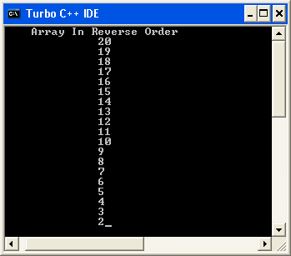

Ex 15: Write an interactive program to do the following computation by providing the option using the switch statement:
(i) Add two matrices.
(ii) Subtract two matrices.
(iii) Multiply two matrices.
Code:

#include<stdio.h>
#include<conio.h>
int arr[3][3],arr1[3][3],arr2[3][3],i,j,sum,k;
void input()
{
printf("\n\n\tEnter Value For first Array\n\n");
for(i=0; i<3; i++)
{
for(j=0; j<3; j++)
{
printf("\t Enter The Value -> ");
scanf("%d",&arr[i][j]);
}
}
printf("\n\n\t\tEnter Value For Second Array\n\n");
for(i=0; i<3; i++)
{
for(j=0; j<3; j++)
{
printf("\t\tEnter The Value -> ");
scanf("%d",&arr1[i][j]);
}
}
}
void display()
{
getch();
clrscr();
for(i=0; i<3; i++)
{
for(j=0; j<3; j++)
{
printf("\t%d",arr2[i][j]);
}
printf("\n\n");
}
}
void addition()
{
input();
//int i,j;
for(i=0; i<3; i++)
{
for(j=0; j<3; j++)
{
arr2[i][j]=arr[i][j]+arr1[i][j];
}
}
}
void sub()
{
//int i,j;
input();
for(i=0; i<3; i++)
{
for(j=0; j<3; j++)
{
arr2[i][j]=arr[i][j]-arr1[i][j];
}
}
}
void multiply()
{
input();
//int i,j,k;
for(i=0; i<3; i++)
{
for(j=0; j<3; j++)
{
arr2[i][j]=0;
for(k=0; k<3; k++)
{
arr2[i][j]=arr2[i][j]+arr[i][k]*arr1[k][j];
}
}
}
}
void main()
{
int ch;
clrscr();
printf("\n\n\t\tEnter Any Choice");
printf("\n\n\t\t1. Addition of Matrix");
printf("\n\n\t\t2. Subtraction of Matrix");
printf("\n\n\t\t3. Multiply of Matrix");
printf("\n\n\t\tEnter Your Choice - ");
scanf(" %d",&ch);
getch();
clrscr();
switch(ch)
{
case 1:
{
addition();
display();
break;
}
case 2:
{
sub();
display();
break;
}
case 3:
{
multiply();
display();
break;
}
default:
{
printf("\n\n\t\tWrong choice");
}
}
getch();
}

Output:

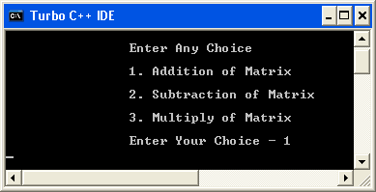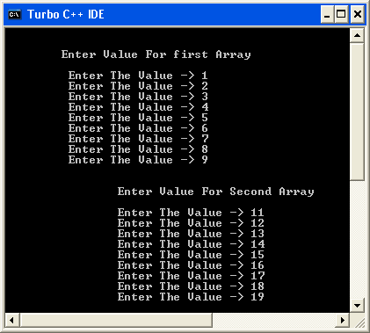

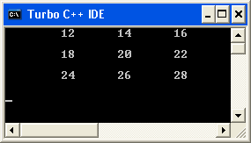

Session 5
Ex 16: Write a program to check if the given matrix is square or not.
Code:
#include<stdio.h>
#include<conio.h>
void main()
{
int intAUserMatrix[3][3];
int i,j;
void check_msquare(int a[3][3]);
clrscr();
printf("\n\n\t Please enter the matrix:\n");
for(i=0;i<3;i++)
{
for(j=0;j<3;j++)
{
printf("\n\t\tMatrix[%d][%d]=", i,j);
}
}
printf("\n\t\tGiven matrix is: ");
for(i=0;i<3;i++)
{
for(j=0;j<3;j++)
{
printf("\n\t\t%d", intAUserMatrix[i][j]);
}
printf("\n");
}
check_msquare(intAUserMatrix);

getch();

}
void check_msquare(int matrix[3][3])
{
int row,col,sumRow[3],sumCol[3];
for(row=0;row<3;row++)
{
for(col=0;col<3;col++)
{
sumCol[col]=sumCol[col]+matrix[row][col];
}
}
for(col=0;col<3;col++)
{
for(row=0;row<3;row++)
{
sumRow[row]=sumCol[row]+matrix[row][col];
}
}

if(sumCol[0]==sumCol[1] && sumCol[0]==sumCol[2] && sumCol[0]==sumRow[0] && sumRow[0]==sumRow[1] && sumRow[0]==sumRow[2])
{
printf("\n\n\t\tMagic Square");
}
else
{
printf("\n\t\tNot a magic square\n");
}
}
Output:

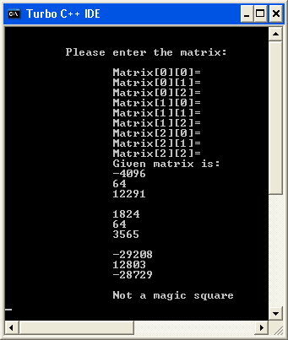

Ex 17: Write a program to print the upper and lower triangle of matrix.

Code:
#include<stdio.h>
#include<conio.h>
void main()
{
int arr[3][3],i,j,k=2;
clrscr();
for(i=0; i<3; i++)
{
for(j=0; j<3; j++)
{
printf("\tEnter value -> ");
scanf("%d",&arr[i][j]);
}
}
printf("\n\n");
for(i=0; i<3; i++)
{
for(j=0; j<=2; j++)
{
if(arr[i]==arr[k])
{
printf("\t-");
k--;
}
else
{
printf("\t%d",arr[i][j]);
k--;
}
}
printf("\n\n");
k=2;
}
getch();
}
Output:
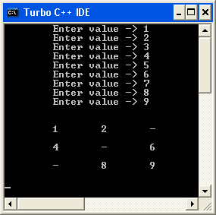

Ex 18: Write a program To compute transpose of a matrix.
Code:
#include<stdio.h>
#include<conio.h>
void main()
{
int arr[3][3],i,j;
clrscr();
printf("\t- Enter Values To Compute Transpose of a Matrix - \n\n");
for(i=0; i<3; i++)
{
for(j=0; j<3; j++)
{
printf("\tenter value -> ");
scanf("%d",&arr[i][j]);
}
}
printf("\n\n");
for(i=0; i<3; i++)
{
for(j=0; j<3; j++)
{
printf("\t\t%d",arr[i][j]);
}
printf("\n\n");
}
printf("\n\n");
for(i=0; i<3; i++)
{
for(j=0; j<3; j++)
{
printf("\t\t%d",arr[j][i]);
}
printf("\n\n");
}

getch();
}

Output:
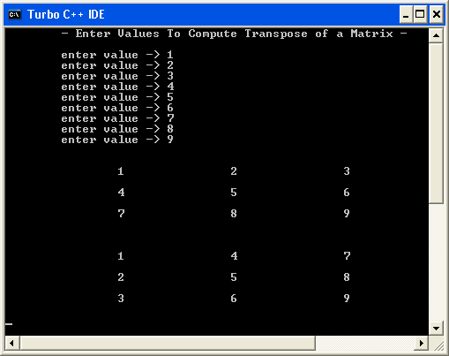

Ex 19: Write a program to find the inverse of a Matrix.

Code:
#include<stdio.h>
#include<conio.h>
void main()
{
int AUserMatrix[3][3];
int i,j;
clrscr();
printf("\n\n\tPlease insert matrix:-\n");
for(i=0;i<3;i++)
{
for(j=0;j<3;j++)
{
printf("\n\tMatrix[%d][%d]=", i,j);
scanf("%d", &AUserMatrix[i][j]);
}
}
printf("\n\t\t Given matrix is :\n\n");

for(i=0;i<3;i++)
{
for(j=0;j<3;j++)
{
printf("\t\t%d",AUserMatrix[i][j]);
}
printf("\n");
}
getch();
}
Output:
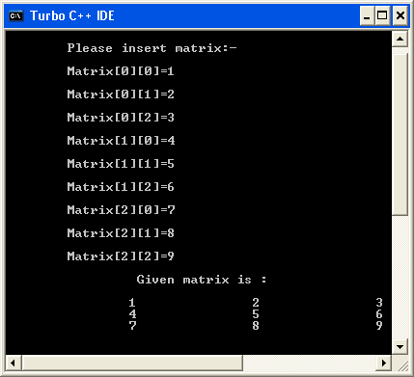

Session 6

Ex 20: Using Recursion, Reverse ‘n’ Characters.
Code:
#include<stdio.h>
#include<conio.h>
#include<string.h>

void reverse(char chrAParam[],int intParamLen)
{

if(intParamLen>-1)
{
printf("%c", chrAParam[intParamLen]);
intParamLen=intParamLen-1;
reverse(chrAParam, intParamLen);
}
}

void main()
{
char chrAUserInput[50];
clrscr();
printf("\n\n\t\tPlease insert string : ");
gets(chrAUserInput);
printf("\n\n\t\t Reverse String is : ");
reverse(chrAUserInput,strlen(chrAUserInput));
getch();
}

Output:
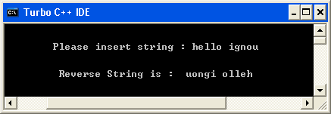

Session 7

Ex 21: Write a program to convert a given lowercase string to upper case string without using the inbuilt string function.
Code:
#include <stdio.h>
#include <conio.h>
#include <string.h>

void main ()
{
char ChrUserLcase[100];
int i ;
clrscr();
printf ("\t\n Plese insert String in Lower Case : -> ");
gets(ChrUserLcase) ;
printf ("\t\n Converted Uper Case String : -> ");
for (i = 0 ; i <=strlen(ChrUserLcase)-1 ; i++)
{
if (ChrUserLcase[i]>=97 && ChrUserLcase[i]<=122 )
{
printf ("%c", ChrUserLcase[i]-32) ;
}
else
{
printf ("%c", ChrUserLcase[i]);
}
}
getch() ;
}
Output:

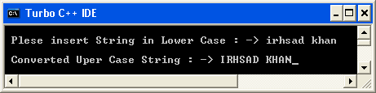

Ex 22: Write a program to count number of vowels, consonants & spaces in a given string.
Code:
#include<stdio.h>
#include<conio.h>
void main()
{
char name[20];
int i,space=0,vowel=0,conso=0;
clrscr();
printf("\n\tEnter Name -> ");
gets(name);
for(i=0; name[i]!=NULL; i++)
{
if(name[i]==' ')
{
space++;
}
else if(name[i]=='a'|| name[i]=='A'|| name[i]=='e'|| name[i]
=='E'|| name[i]=='i'|| name[i]=='I'|| name[i]=='o'
|| name[i]=='O' || name[i]=='u' || name[i]=='U')
{
vowel++;
}
else
{
conso++;
}
}
printf("\n\n\tYour Total Space is %d",space);
printf("\n\n\tYour Total Vowel is %d",vowel);
printf("\n\n\tYour Total Conso. is %d",conso);
getch();
}
Output:
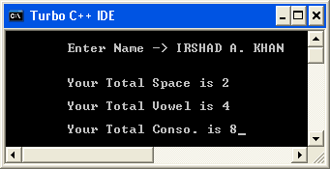

Ex 23: Write a program to input a string and output the reversed string, i.e. if "USF" is input, the program has to output "FSU". You are not to use array notation to access the characters, instead please use pointer notation.
Code:

#include<stdio.h>
#include<conio.h>
void main()
{
char name[20],*p;
int i,j=0,k;

clrscr();
printf("\n\tEnter Any String -> ");
gets(name);
for(i=0; name[i]!=NULL; i++)
{
j++;
}
p=&name[j-1];
printf("\n\n\t\t");
for(i=j-1; i>=0; i--)
{
printf("%c",*p);
p--;
}
getch();
}

Output:
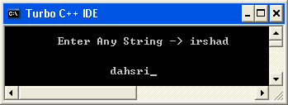

Session 8

Ex 24: Write a program to process the students-evolution records using structures.
Code:

#include<stdio.h>
#include<conio.h>
struct student
{
char r_no[10],name[20];
int h,e,m;
}i;
void main()
{
clrscr();
printf("\n\tEnter Your Roll_No -> ");
gets(i.r_no);
printf("\n\tEnter Your Name -> ");
gets(i.name);
printf("\n\tEnter Your Marks In Hindi -> ");
scanf("%d",&i.h);
printf("\n\tEnter Your marks In English -> ");
scanf("%d",&i.e);
printf("\n\tEnter Your marks In Maths -> ");
scanf("%d",&i.m);

printf("\n\n\t\tYour R_no is %s",i.r_no);
printf("\n\n\t\tYour Name is %s",i.name);
printf("\n\n\t\tYour Marks in Hindi %d",i.h);
printf("\n\n\t\tYour Marks in English %d",i.e);
printf("\n\n\t\tYour Marks in maths %d",i.m);
getch();
}
Output:
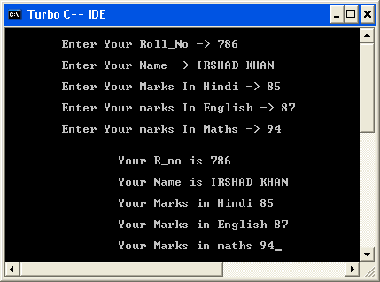

Ex 25: Define a structure that will hold the data for a complex number. Using this structure, please write a program that will input two complex numbers and output the multiple of two complex numbers. Use double variables to represent complex number components.
Code:
#include<stdio.h>
#include<conio.h>
typedef struct
{
double rl;
double im;
}
complex;

void main()
{
complex a,b,c;
clrscr();
printf("\n\n Enter the first complex No.:-> ");
scanf("%lf%lf",&a.rl,&a.im);
printf("\n Enter the second complex No.:-> ");
scanf("%lf%lf",&b.rl,&b.im);
c.rl=(a.rl*b.rl)-(a.im*b.im);
c.im=(a.rl*b.im)+(b.rl*a.im);
printf("\n The multiple of the two complex numbers are:=> %.2lf\+%.2lfi",c.rl,c.im);
}
Output:
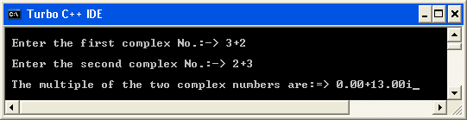

Session 9

Ex 27: Write a function that will return the length of a character string. You are not allowed to use the strlen C library function.
Code:
#include<stdio.h>
#include<conio.h>
void main()
{
char name[20],*p;
int i,j=0,k;
clrscr();
printf("\n\tEnter any String -> ");
gets(name);
p=&name[0];
printf("\n\t");
for(i=0; name[i]!=NULL; i++)
{
printf(" %c",*p);
p++;
j++;

}
printf("\n\n\n\t\tYour String Length is %d",j);
getch();
}

Output:
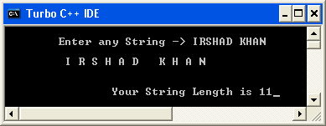

Ex 29: Write a sample program that uses this function to find the display the minimum and the maximum values of an array of integers. Use an array of 10 integers. You can either use scanf to input the values into that array or initialize the array with values in the program itself.

Code:

#include<stdio.h>
#include<conio.h>
int arr[10],i,val,val1;
void input()
{
for(i=0; i<10; i++)
{
printf("\n\tEnter value -> ");
scanf("%d",&arr[i]);
}
clrscr();
getch();
}
void display()
{
for(i=0; i<10; i++)
{
printf("\n\n\t\t%d",arr[i]);
}

}
void min()
{
val=arr[0];
for(i=0; i<10; i++)
{
if(val>arr[i])
{
val=arr[i];
}
}
printf("\n\n\t\tYour Minimum value is %d",val);
}
void max()
{
val1=arr[0];
for(i=0; i<10; i++)
{
if(arr[i]>val1)
{
val1=arr[i];
}
}
printf("\n\n\t\tYour Maximum value is %d",val1);
}
void main()
{
clrscr();
input();
display();
min();
max();
getch();
}\

Output:
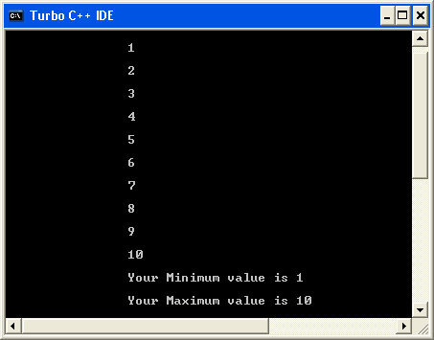

Session 10

Ex 30: Write a program that prompts the user the name of a file and then counts and displays the number of bytes in the file. And create a duplicate file with the word '.backup' appended to the file name. Please check whether file was successfully opened, and display an error message,if not.

Code:

#include<stdio.h>
#include<conio.h>
#include<process.h>
#include<string.h>
void main()
{
int IntFileSize=0,i;
char chUserFile[20],c;
FILE*F1User,*F1Bak;
clrscr();
printf("\n Please insert Filename & Extansion -> ");
scanf("%s", chUserFile);

F1User=fopen(chUserFile,"r");
if(F1User==NULL)
{
printf("File does not exist or File I/O Error");
getch();
exit(0);
}
strcat(chUserFile,".backup");
F1Bak=fopen(chUserFile,"w");
if(F1User==NULL)
{
printf("File I/O Error!");
getch();
exit(0);
}
while((c=getc(F1User))!=EOF)
{
putc(c,F1Bak);
IntFileSize++;
}

printf("\n file is %d bytes", IntFileSize);
fclose(F1User);
fclose(F1Bak);
getch();
}

Output:

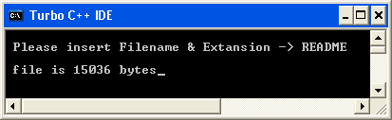

Ex 31: Write a program to create a file, open it, type-in some character and count the no. of char. in file.

Code:

#include<stdio.h>
#include<conio.h>
#include<process.h>
#include<string.h>
void main()
{
int IntFileSize=0;
FILE *FIUser;
char chUserFile[20];
char chUserInput[100];
clrscr();
printf("\nPlease Insert File to Create:-> ");
gets(chUserFile);

FIUser=fopen(chUserFile,"w");

if(FIUser==NULL)
{
printf("File Creation Error");
getch();
exit(0);
}
printf("\n Please Insert Character into File:=> ");
gets(chUserInput);
fputs(chUserInput,FIUser);
fclose(FIUser);
FIUser=fopen(chUserFile,"r");
while(getc(FIUser)!=EOF)
{
IntFileSize++;
}
printf("\n size of file is %d",IntFileSize);
fclose(FIUser);
getch();
}

Output:

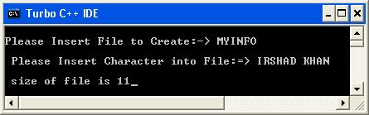

Ex 32: Write a program that will input a person's first name,last name, SSN number and age and write the information to a data file. One person's information should be in a single line. Use the function fprintf to write to the data file. Accept the information & write the data within a loop. Your program should exit the loop when the word 'EXIT' is entered for the first name. Remember to close the file before terminating the program.

Code:

#include <stdio.h>
#include <conio.h>
#include <process.h>
#include <string.h>

struct Datastru{
char fname[20] ;
char lname[20] ;
int SSNno ;
int age ;
}

main ()
{
struct Datastru StPerson ;

FILE *FlUser;
char chUserFile[20] ;
char chUserInput[100] ;

int i;
printf("\nPlease Insert data File to Create:-> ") ;
scanf("%s",chUserFile);

FlUser = fopen(chUserFile,"w");
if(FlUser == NULL)
{
printf("File Creation Error");
getch() ;
exit(0);
}

while (strcmp(StPerson.fname,"EXIT") != 0 )
{
printf("\nPlease Insert person's First Name :-> ") ;
scanf("%s",&StPerson.fname);
if(strcmp(StPerson.fname,"EXIT") == 0 )
{
fclose(FlUser) ;
exit(0);
}
fprintf(FlUser,"%s",&StPerson.fname) ;
printf("\nPlease Insert person's Last Name :-> ") ;
scanf("%s",&StPerson.lname);
fprintf(FlUser,"%s",&StPerson.lname) ;
printf("\nPlease Insert person's Age :-> ") ;
scanf("%d",&StPerson.age);
fprintf(FlUser,"%d",StPerson.age) ;
printf("\nPlease Insert person's SSN No :-> ") ;
scanf("%d",&StPerson.SSNno);
fprintf(FlUser,"%d",StPerson.SSNno) ;
fprintf(FlUser,"\n") ;
}
fclose(FlUser) ;
}

Output:

